Bangladesh University Of Business & Technology



LAB REPORT

Course Code : CSE-207

Course Title : Database Systems

Experiment Name : Create database & table, Insert data in table and solving the questions from the tables using xampp software.

Experiment No. : 02

Intake : 45

Section : 02

Program : B.sc. Engg in CSE

SUBMITTED BY : Shamsi Juma(068)

SUBMITTED TO : Zobaer Zihad (Lecturer, Department of CSE, BUBT)

Create customer table:

CREATE TABLE customer_table ( customer_name varchar(250), customer_street varchar(250), customer_city varchar(250), PRIMARY KEY (customer_name ) );

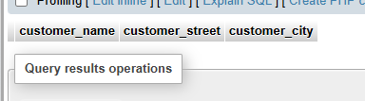

Insert value for customer_table:

INSERT INTO customer_table VALUES

('Adams', 'Spring', 'Pittsfield'),

('Brooks', 'Senator', 'Brooklyn'),

('Curry', 'North', 'Rye'),

('Glenn', 'Sand Hill', 'Woodside'),

('Green', 'Walnut', 'Stamford'),

('Hayes', 'Main', 'Harrison'),

('Johnson', 'Alma', 'Palo Alto'),

('Jones', 'Main', 'Harrison'),

('Lindsay', 'Park', 'Pittsfield'),

('Smith', 'North', 'Rye'),

('Turner', 'Putnam', 'Stamford'),

('Williams', 'Nassau', 'Princeton');

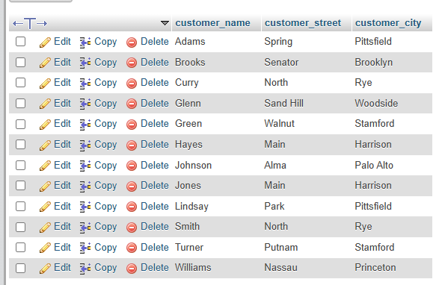

Create loan_table:

CREATE TABLE loan_table ( loan_number varchar(250), branch_name varchar(250), amount INT );

And Insert value:

INSERT INTO loan_table VALUES

('L-11', 'Round Hill', 900),

('L-14', 'Downtown', 1500),

('L-15', 'Perryridge', 1500),

('L-16', 'Perryridge', 1300),

('L-17', 'Downtown', 1000),

('L-23', 'Redwood', 2000),

('L-93', 'Manus', 500);

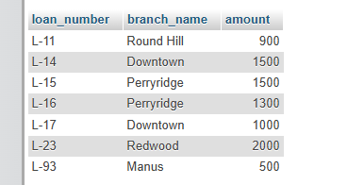

CREATE TABLE borrow_table ( customer_name varchar(250), loan_number varchar(250), PRIMARY KEY (customer_name, loan_number),FOREIGN KEY (customer_name) REFERENCES customer_table(customer_name), FOREIGN KEY (loan_number) REFERENCES loan_table(loan_number) );

INSERT INTO borrow_table VALUES

('Adams', 'L-16'),

('Curry', 'L-93'),

('Hayes', 'L-15'),

('Johnson', 'L-14'),

('Jones', 'L-17'),

('Smith', 'L-11'),

('Smith', 'L-23'),

('Williams', 'L-17');

Q:1: Find the names of all customers whose name start with ”G”.

SELECT customer_name from customer_table where customer_name LIKE 'G%';

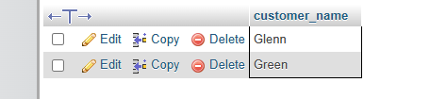

Q.2. Find the largest , minimum and average loan amount in the

“Loan” relation.

Code: SELECT MAX(amount)AS largr_amount FROM loan_table;

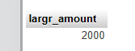

SELECT MIN(amount)AS low_amount FROM loan_table;

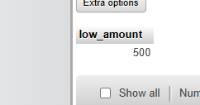

SELECT AVG(amount)AS average_amount FROM loan_table;



Q.3. Find the total number of customer from “Customer” relation.

SELECT COUNT (customer_name) from customer_table;

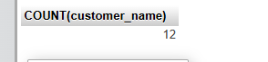

Q4. Find the loan number of those loans with loan amounts between

400 and 800.

SELECT amount FROM loan_table WHERE amount BETWEEN 400 and 800;

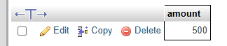

q.5. Find the names of all customers whose name ends with ”s”.

SELECT * FROM customer_table WHERE customer_name LIKE '%S';

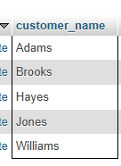

q.6. Find the names of all customers whose name has a “o” in 2nd

position.

SELECT * FROM customer_table WHERE customer_name LIKE '_%O%';

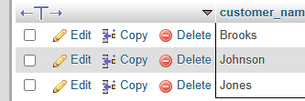

q.7. Find the names of all customers whose name has a “o” in any

position except 1st and last letter.

SELECT * FROM customer_table WHERE customer_name LIKE '_%O%_';

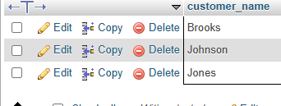

q.8. Find the length of the name of all customers from “Customer”

realtion.

SELECT customer_name,LENGTH(customer_name)AS name_length FROM customer_table;

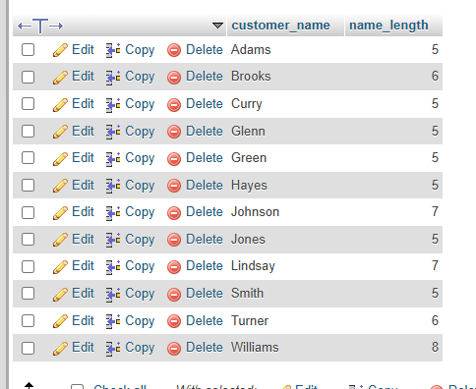

q.9. Find 1st three characters of each customer name from “customer” relation.

SELECT customer_name,SUBSTRING(customer_name,1,3)AS first_three_chars FROM customer_table;

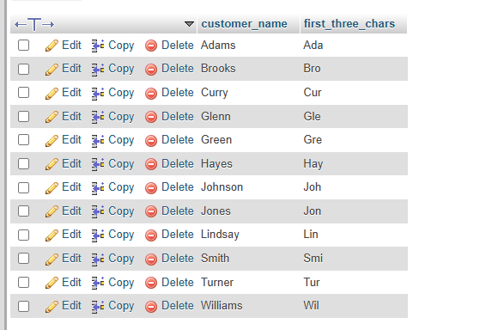

10. Find the total no. of loans from “Loan” relation from each

branch.

SELECT branch_name,COUNT(loan_number)AS total_loans FROM loan-table GROUP BY branch_name;

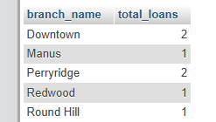

11.

Find the 2nd letter of customer_city for the branch_name

“Downtown”.

SELECT SUBSTRING(customer_city 2,1) AS second_letter

FROM customer_table

WHERE customer_name IN(

SELECT customer_name

FROM borrow_table

WHERE loan_number IN(

SELECT loan_number

FROM loan_table

WHEREbranch_name='Downtown'

)

);